**SPRING BOOT WIT REST API**

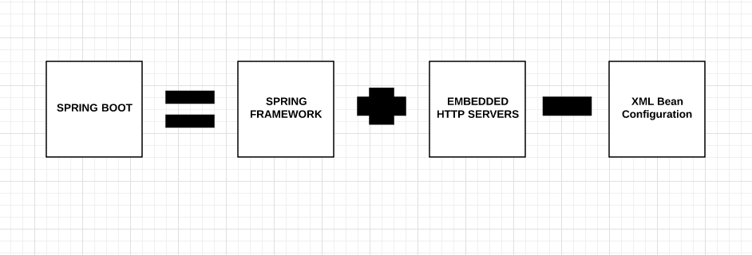

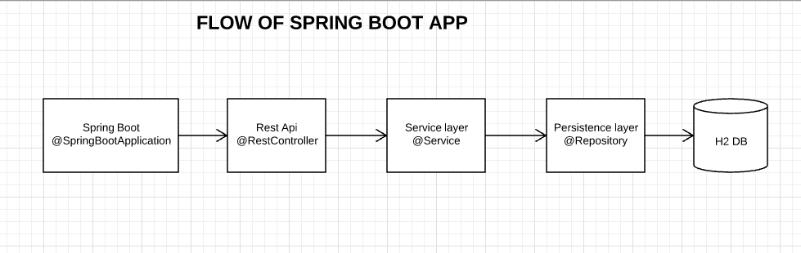

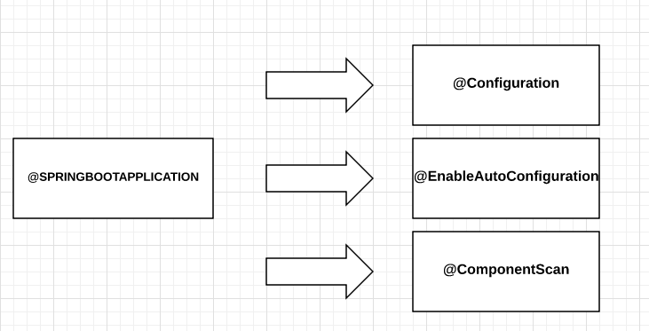

**CRUD Operations on a Course**

**Course:**

1. **CourseId**
2. **CourseName**
3. **Topic**
4. **Duration**
5. **Status**

